INTRODUCTION

* 1. **Overview**

A designer plays a key role in a Creative company. Using elements like typography illustration photography and layout a designer always has an extremely creative mind that can absorb visual trends and deploy then in fresh and exciting ways

* 1. purpose

Professional designers understand a company’s business and how to translate them into quality work. They leverage their education and creativity to design graphics that convey the organization’s message in a way audiences enjoy and remember.

**2 Problem Definition & design thinking**

2.1 **Empathy map**

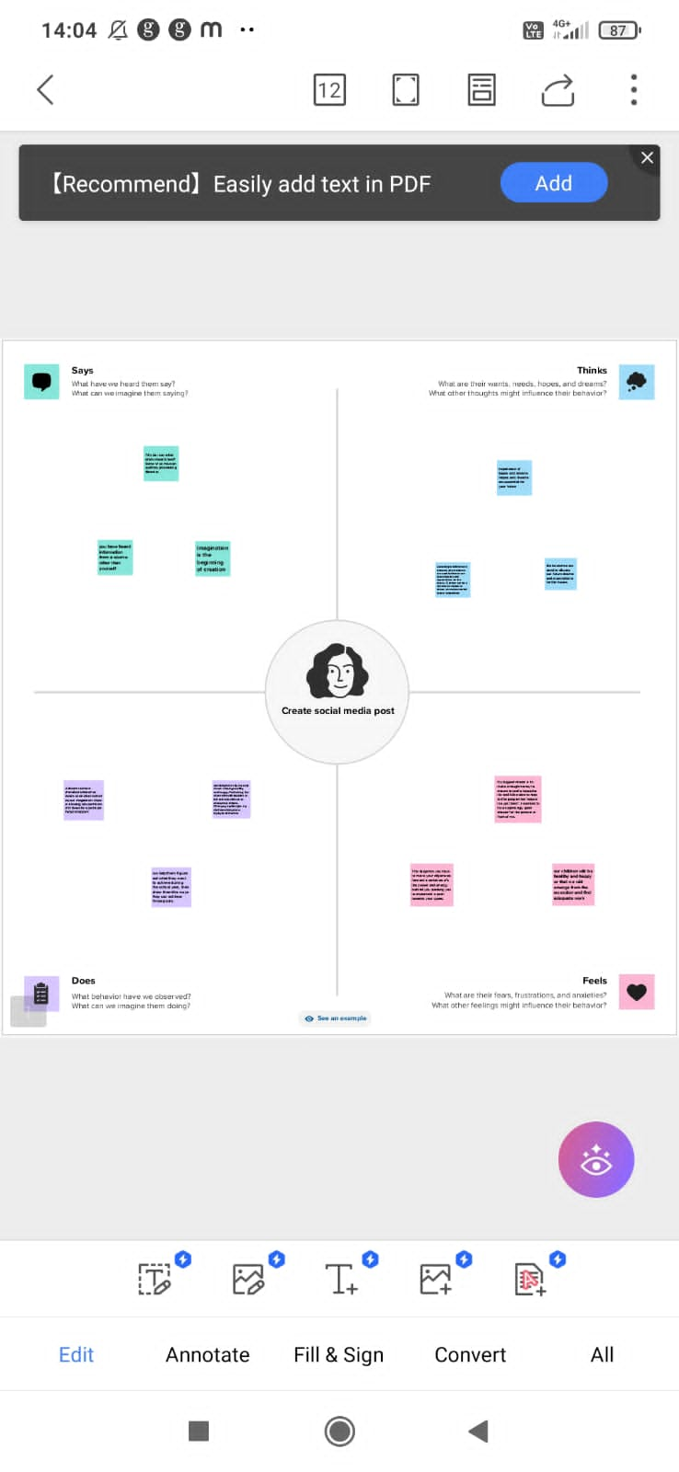

2.2 Ideation & Brainstorming map

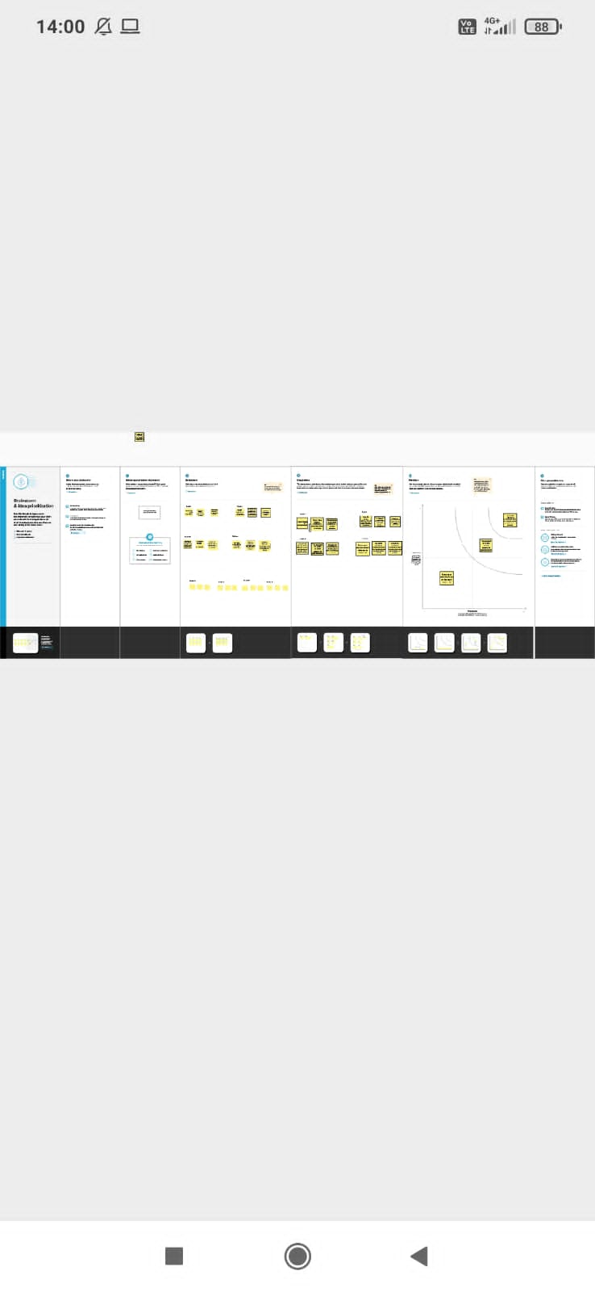

3 RESULT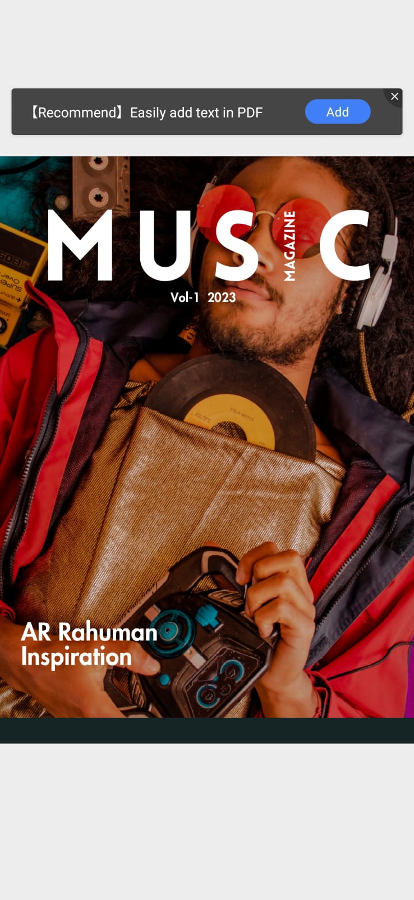

4 ADVANTAGES & DISADVANTAGES

**4.1 Advantage**

Can Make Money on Side

Good Life Balance

Can get Benefit from Social Sites

**4.2 Disadvantages**

|  |
| --- |
| Relying on your Parents |
| Limited Promotions    May Feel Lonely  **5 APPLICATION**  We used Mural Application and Canva application    **6 CONCLUSION**  We have created book cover with the help of canva  **7 FUTURE SCOPE**  We were planning to join the Graphic Designing course |